**Coding Assessment – Apply Transformation and actions in Pyspark**

**By Afreen Sultana A**

**Transformation**

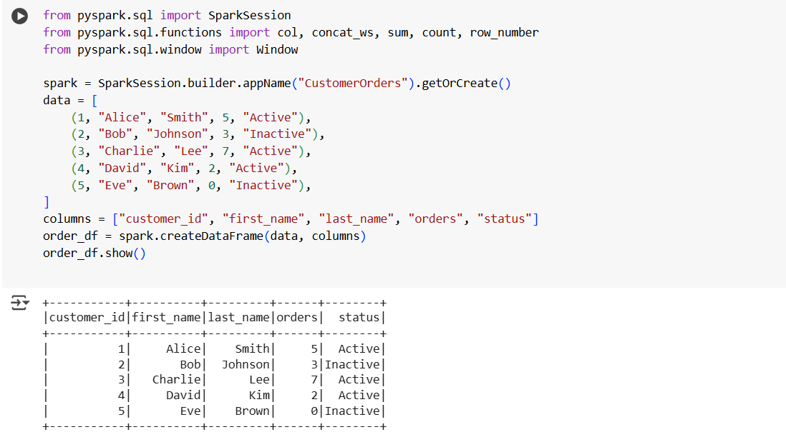

1. **select()** – Select specific columns

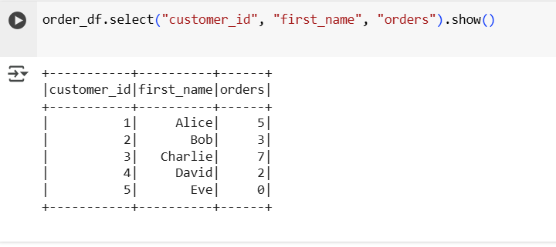

1. **filter() and where()** - Filter rows by condition

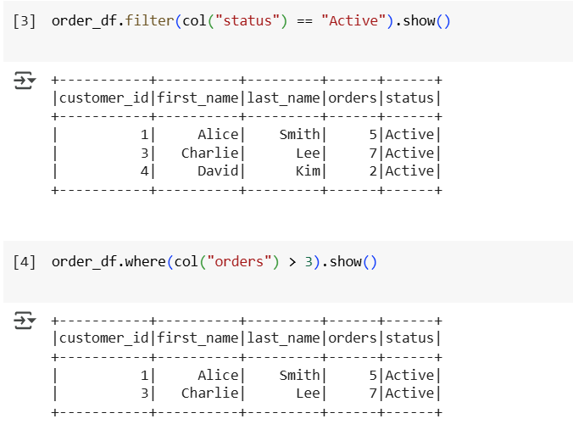

1. **withColumn()** – Add new column or modify existing

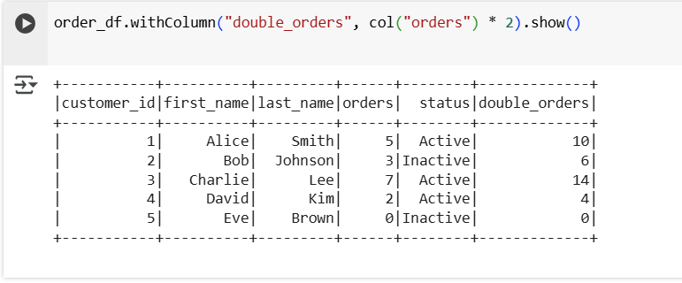

1. **drop()** – Drop a column

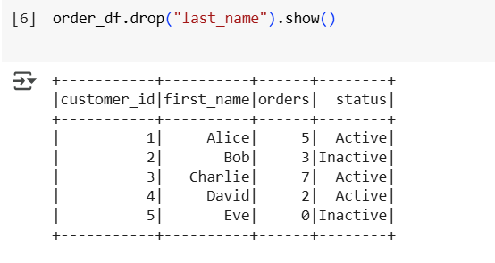

1. **distinct()** – Get unique rows

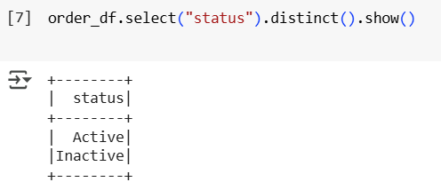

1. **dropDuplicates()** – Drop duplicate rows

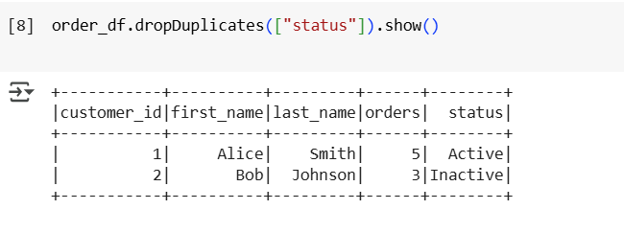

1. **groupBy() + agg()** – Group and aggregate

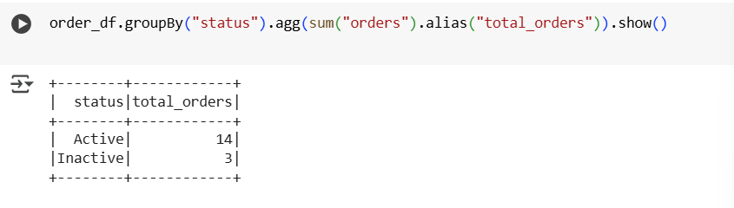

1. **orderBy()**  – Sort rows

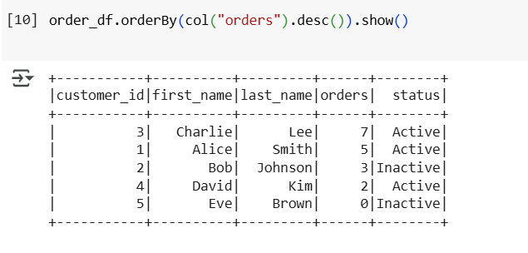

1. **join()** – Join with another DataFrame

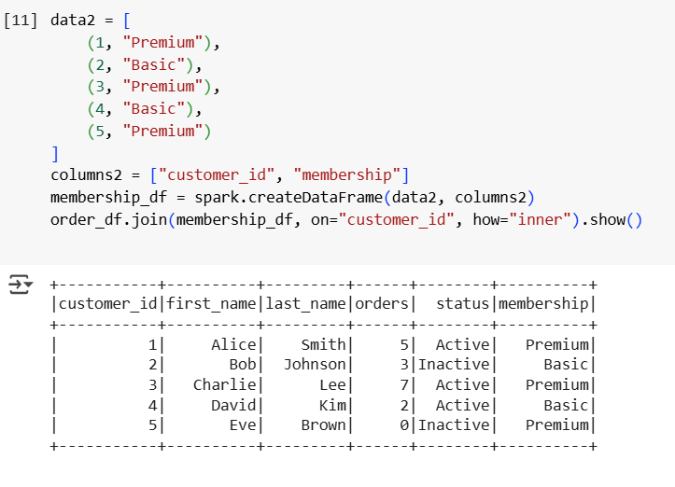

1. **union()** – Combine two DataFrames with same schema

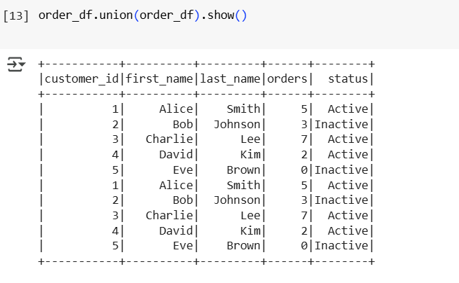

1. **limit()** – Limit rows

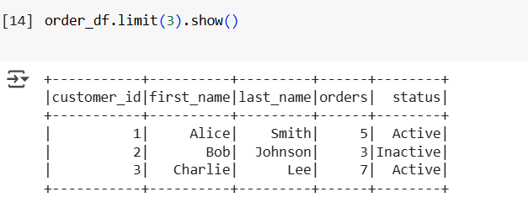

1. **selectExpr()** – SQL expressions inside select

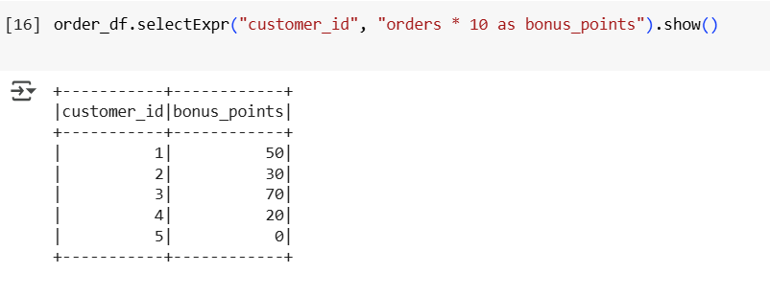

1. **cache()** – Store result in memory

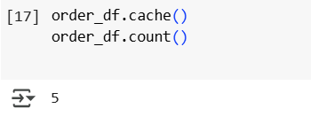

1. **Window Functions** – Ranking, row numbers

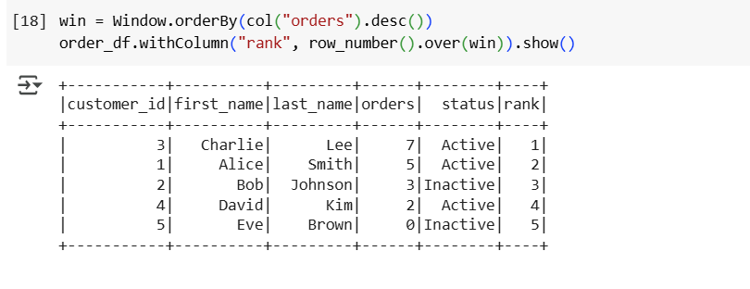

**Actions**

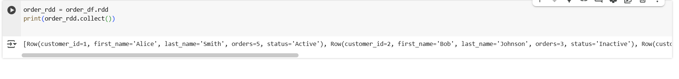

1. **.collect() Action**



1. **.count() Action**

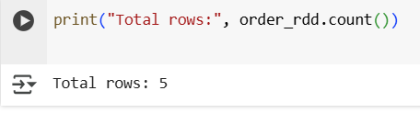

1. **.first() Action**

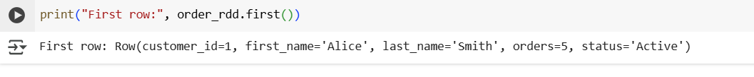

1. **.take(n) Action**



1. **.reduce() Action**

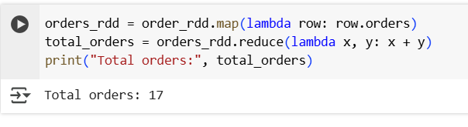

1. **.saveAsTextFile() Action**

